# Preliminary report on “Simplified energy balance snowmodelling”

Thomas Skaugen, HB.

## Introduction

It has, since long, been an ambition to introduce energy balance (EB) modeling into the suite of snow models at HB, NVE. One reason is that it will enhance the competence and insight of the snow modellers at NVE, another is the fact that several studies have shown that at finer temporal resolutions than daily, an energy balance approach is superior to that of the degree day approach used today. A third reason is that the input data available at some locations now comprises, wind speed and -direction, short wave- and long wave radiation, detailed temperature measurements at several horizontal layers etc. Also, Vormoor and Skaugen (2012) recently presented 3 hourly gridded (1 X 1 km) precipitation and temperature for all of Norway, with the objective of facilitating hydrological modeling (which necessarily includes snow modeling in Norway) at finer temporal resolution.

In spite of examples of increased detail in meteorological data represented by, e.g. radiation and wind measurements, there is no indication that input data necessary for detailed EB modeling will be available for all of Norway at suitable temporal resolutions in the foreseeable future. Consequently, precipitation and temperature are the two meteorological input variables on which an EB approach to snow modeling have to be based. A possible gain in model results will hence be due to finer temporal resolutions of said input. The limited meteorological information makes it necessary to use approximate relations to express quantities such as snowpack temperature, snow surface temperature, cloud cover, etc as functions of precipitation and air temperature.

This study outlines a EB snow model were most of the governing equations are shamelessly copied from other authors with the aim of investigating the accuracy of an EB approach using only precipitation and air temperature as input.

## The model

The daily energy budget of a column of snow is expressed as (Walter et al. 2005):

(1)

and melt is estimated as:

Where is the latent heat of fusion (), [ is the density of water, is the change in the snowpack’s water equivalent [], *S* []is the net incident solar (short wave) radiation, [] is the atmospheric long wave radiation, [] is the terrestrial long wave radiation, *H* [] is the sensible heat exchange, [] is the energy flux associated with the latent heats of vaporization and condensation at the surface, *G* [] is ground heat conduction to the bottom of the snowpack, [] is heat added by precipitation and [] is the change of snowpack heat storage. These fluxes are not routinely measured at a frequency and spatial coverage useful for operational national snow modeling, and the following will describe how these quantities are estimated as functions of location, time of year, precipitation and air temperature.

### 2.1 Solar radiation

The solar radiation striking a horizontal surface is:

(2)

where [ is the potential solar radiation on a horizontal surface and readily estimated as:. is the albedo and estimated for old snow according to the empirical equation of US Army Corps of Engineers (1960) (Walter et al, 2005) as :

(3)

Where is the maximum albedo and assumed equal to (Walter et al. 2005), and is the albedo of the previous time step (is eq. 3 only valid for 24 hours??). In the case of new-fallen snow, the snow covers darker old snow and Walter et al. (2005) suggested the following equation for estimating the albedo:

(4)

where  is the density of new fallen snow and estimated as where is air temperature (Walter et al., 2005; after Goodison et al., 1981).

The variable is the net daily average sky transmissivity (Liston, 1995) and accounts for the scattering, absorption, and reflection of solar radiation:

(5)

Here a discrepancy between Listons papers (Liston, 1995; Pielke et al, 2004, Liston and Elder, 2006) and other authors are found. In Bacellar et al. 2008, the transmissivity is modeled as +, where is again the solar zenith angle. The expressions and are interchangeable. The expression of Bacellar et al. (2008) is confirmed against observations and also provide good results in this study and is hence used in the following.

The variable is the fractional cloudcover and estimated as zero if precipitation and 1 if not. The solar elevation angle is defined as (Dingman, 2001):

(6)

where is the latitude in radians, is the solar declination angle in radians and equal to (Liston 1995): ( is the Gregorian day number) and is the number of hours from solar noon, which gives . The variable used in eq. 5, is the value of averaged over the number of hours in each time step and is the solar zenith angle Dingman (2002), whereas the angle used in Liston (1995) is the solar elevation angle. These two angles are complementary to . (An algorithm transforming UTM (zone 33) coordinates to latitude and longitude is included in the appendix).

### 2.1.1 Solar radiation for less than daily.

In order to calculate the number of hours with solar radiation, the sunrise () (hour) and sunset () (hour) at the chosen location and day of year have to be determined. From algorithms found on the net we have:

(7)

and

(8)

where

(9)

and

(10)

where

(11)

and where is the radius of the earth, [km], , is the distance to the sun [km], and . The time zone is calculated as: , where is the longitude.

### 2.1.2 Alternative algorithm for the estimation of albedo.

The “Utah Energy Balance Snow Accumulation and Melt Model (UEB) (Tarboton and Luce, 1996) proposes an algorithm for estimating albedo as a function of snow surface age and solar illumination angle, which follows Dickinson et al. (1993).

Reflectance is computed for two bands, visible () and near infrared (). The albedo, is the average of the two reflectances:

Where and represent diffuse reflectances in the visible and near infrared bands. The constants and quantify the sensitivity of the respective band albedo to snow surface aging (grain size growth) and and are fresh snow reflectances in each band. The variable accounts for the aging of the snow surface and is given by

Where is a non-dimensional snow surface age (starts as =0, for fresh snow) that is incremented at each times step by the quantity designed to emulate the effect of the growth of surface grain sizes:

Where is the time step in seconds with .

The parameter depends on snow surface temperature( in here) intended to represent the effect of grain growth due to vapor diffusion:

The parameter represents the additional effect near and at freezing point due to melt and refreeze

And, finally, represents the effect of dirt and soot.

0.01m of snowfall ( is assumed to restore the snow surface to new conditions (=0). With snowfall less than that in a time step, the dimensionless snow age is reduced by a factor (1-100.

The reflectance of radiation with illumination angle (the zenith angle of Dingman, 2001, measured relative to the surface normal) is computed as:

Where

for

otherwise

The parameter is set at 2 by Dickinson et al. (1993). The above equation increases reflectance for illumination angles larger than .

When the snowpack is shallow, ( < ), the albedo is taken as

Where , which interpolates between snow albedo and bare ground albedo ( with the exponential term approximating the exponential extinction of radiation penetrating snow.

### 2.2 Long wave radiation

The equations for atmospheric () and terrestrial ( ) long wave radiation are adapted from Walter et al. (2005) and based on the Stefan- Boltzman equation: where the Stefan-Boltzman constant is :

An estimate of atmospheric emissivity is (Campbell and Norman, 1998):

(12)

where the fractional cloud cover is estimated as in Eq. 5. The longwave atmospheric radiation is thus:

(13)

and estimating the emissivity of snow as a grey body, i.e. the longwave terrestrial radiation is:

(14)

Where is the snow surface temperature (°).

### 2.3 Turbulent fluxes - sensible and latent heats

## Sensible heat exchanges between surface and air is calculated with (Dingman, 2002, p. 197):

(15)

Where is the heat capacity of air [, , is the density of air [, is von Karman’s constant, the height of the wind speed and air temperature measurements (, is the roughness height (), , is the zero-plane displacement height (. is the average snowpack temperature (see subsection 2.6). This quantity changes sign dependent on the direction of the temperature gradient. Energy is lost if the snow is warmer than the atmosphere and is negative.

Latent heat exchange between land surface and the atmosphere is governed by the same turbulent process as that of sensible heat exchange and is calculated from (Dingman, 2002):

If the snow surface temperature is less than zero (:

(16)

, and if the snow surface temperature is equal to zero (:

(17)

Where and are the latent heats involved in fusion and vaporization-condensation respectively (, , is the air pressure (, and and are saturation vapor pressure in the atmosphere and at the surface respectively and can be estimated as (Dingman, 2002, p. 586, see also Walter et al. 2005)):

(18)

and

(19)

## *2.4 Ground heat conduction*

Heat conduction from the ground to the snowpack is considered small and a constant in this model (from Walter et al. 2005 and the US Army Corps of Engineers (1960))

(20)

## *2.5 Precipitation heat.*

We assume rainwater has the same temperature as air and that heat is added to the snowpack when the rain’s temperature is lowered to zero degrees:

(21)

## Where is the heat capacity of water () and is rainfall []

*2.6 Cold content in snowpack*

The change of heat storage in the snowpack is estimated as:

(22)

Where is the heat capacity of snow ( and is an estimate of the snow pack temperature calculated as a weighted average of the air temperature for days previous to current time step. is are calculated as:

(23)

Where the weights are decreasing linearly with time, sum up to one, and are calculated as

(24)

*2.7 Iteration of snowpack- and snow surface temperatures*

In winter with cold- conditions, the energy balance is very volatile and at times when the temperatures of the snowpack is estimated to be much colder than the air temperature, we might have a transfer of energy to the snowpack that creates an energy surplus that leads to melting, even when the temperature of both the snowpack and the air are negative. This feature is remedied in the model with an adjustment of the snowpack (and snow surface-) temperature. If the model predicts melt (, the net energy change () needed to produce the melt (Dingman, 2002, p.191) is :

(25)

The energy quantity,, can also be converted into a snowpack temperature change ( (Dingman, 2002, p.191):

(26)

The increase in snowpack temperature is added to the previously estimated snowpack temperature (Eq. 23), an adjusted snow surface temperature () is estimated () and the energy balance (Eq. 1) is recalculated. This procedure reduces very efficiently the undesired melting events during cold conditions through decreasing the temperature difference between air and snowpack and hence changing the direction of the energy flow from the snowpack to the atmosphere. Note that this is a much simpler procedure than that used in e.g. Tarboton and Luce (1996) and avoids the use of tuning parameters.

## Structure of model

## Figure 1. shows the structure of the model. The alternative snowmelt modeling is implemented in the nedb\_eb subroutine of the Senorge1D R-model.

EB_struktur.tif

Figure1. Structure of the Senorge1D\_EB model.

## Results

The model was run as is, with input data (precipitation and temperature) from seNorge simulating SWE [mm], melt [mm], snowdepth [cm], snowdensity and radiaton elements without any calibration. All variables which are normally input to EB type models and which are not expressed as functions of precipitation and temperature are set as constants with values:

1.75 Wind speed [m/s]

101.1 Air pressure, [HPa]

Table 1 shows the Nash-Suthcliffe result for simulating SWE for 31 snowpillows

Table 1. Nash- Suthcliffe criterion (NS) for simulating SWE measured at 31 snowpillows.

|  |  |  |  |
| --- | --- | --- | --- |
| Snow station | NS\_EB | NS\_DG | NS\_SN |
| 2.36 | **-1.75** | -2.22 | -2.13 |
| 2.70 | 0.43 | **0.48** | 0.46 |
| 2.72 | **0.67** | 0.54 | 0.49 |
| 2.97 | -5.93 | **-5.81** | -6.50 |
| 2.373 | 0.91 | **0.94** | **0.94** |
| 2.382 | **-1.36** | -2.0 | -2.22 |
| 2.439 | **-2.1** | -2.64 | -2.87 |
| 2.451 | **0.52** | 0.46 | 0.33 |
| 8.5 | **0.43** | 0.41 | 0.33 |
| 12.142 | **-0.37** | -0.72 | -0.89 |
| 15.118 | **-5.55** | -7.16 | -7.85 |
| 16.232.14 | **-5.1** | -5.55 | -6.03 |
| 19.53 | -18.11 | **-13.91** | -16.95 |
| 19.78 | **-0.27** | -0.51 | -0.84 |
| 21.127 | **-1.02** | -1.71 | -2.20 |
| 26.67 | **-3.69** | -3.93 | -4.59 |
| 62.21 | **-0.63** | -1.26 | -1.59 |
| 73.11 | **-3.35** | -3.97 | -4.28 |
| 88.21 | **-0.22** | -0.47 | -0.67 |
| 121.2 | -1.41 | **-1.38** | -1.93 |
| 123.77 | 0.36 | **0.37** | 0.31 |
| 123.93 | -0.42 | -0.24 | **-0.2** |
| 139.4 | 0.75 | **0.76** | 0.68 |
| 156.63.3 | **0.66** | 0.49 | 0.36 |
| 164.120 | **-0.97** | -1.32 | -1.67 |
| 196.6 | 0.17 | 0.51 | **0.56** |
| 196.47.2 | 0.15 | 0.70 | **0.77** |
| 212.10 | **0.56** | 0.43 | 0.35 |
| 212.23 | **0.65** | 0.58 | 0.56 |
| 213.7 | 0.78 | **0.91** | 0.89 |
| 234.9 | **0.60** | 0.28 | 0.16 |

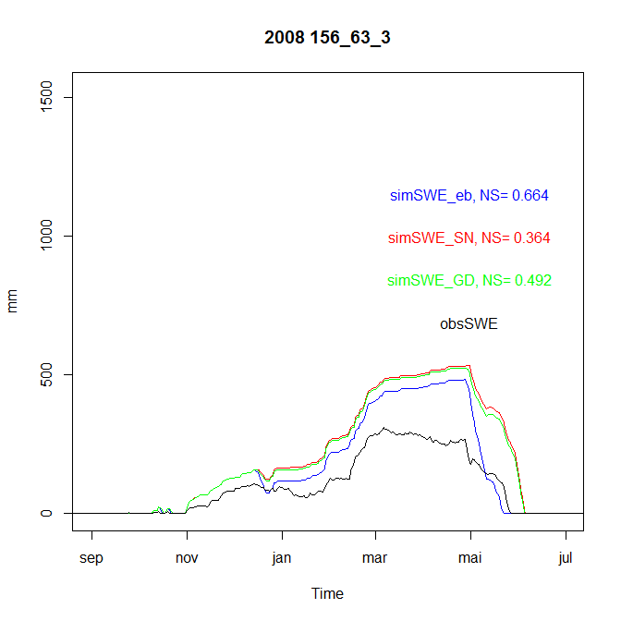

Figure 2. Simulated and observed SWE for the season 2007-8 for the station 156\_63\_3. Blue line is SWE simulated by the the energy balance approach, red line is the official Senorge SWE values for this site, and green line is SWE simulated by the Senorge1D using a degree-day approach.

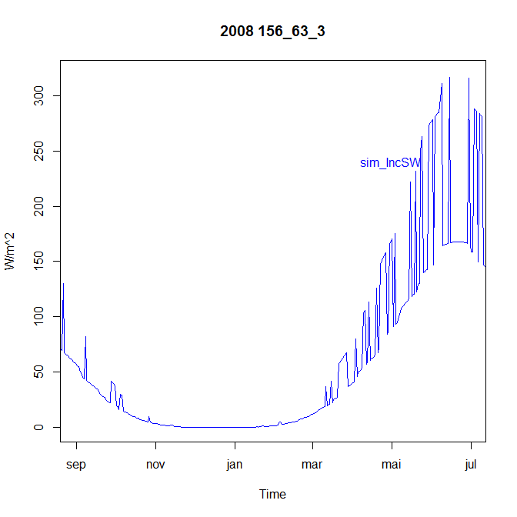

Figure 3. Simulated solar radiation for the season 2007-8 for the station 156\_63\_3.

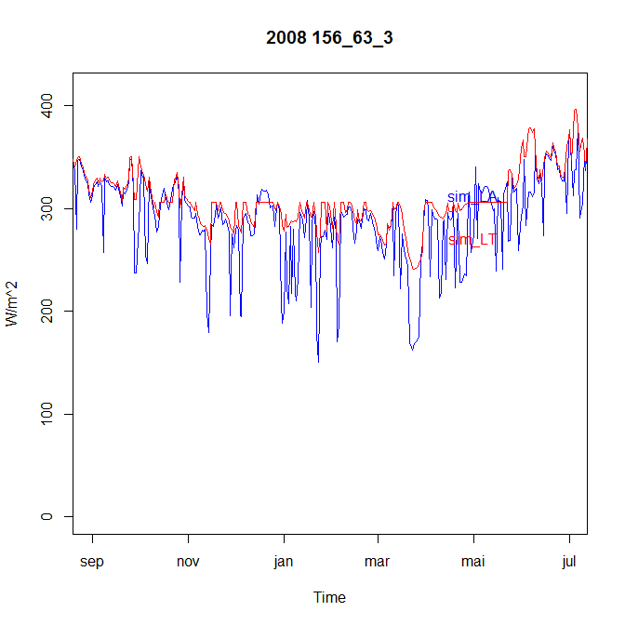

Figure 4. Simulated long wave terrestrial (red) and atmospheric (blue) radation for the season 2007-8 for the station 156\_63\_3.

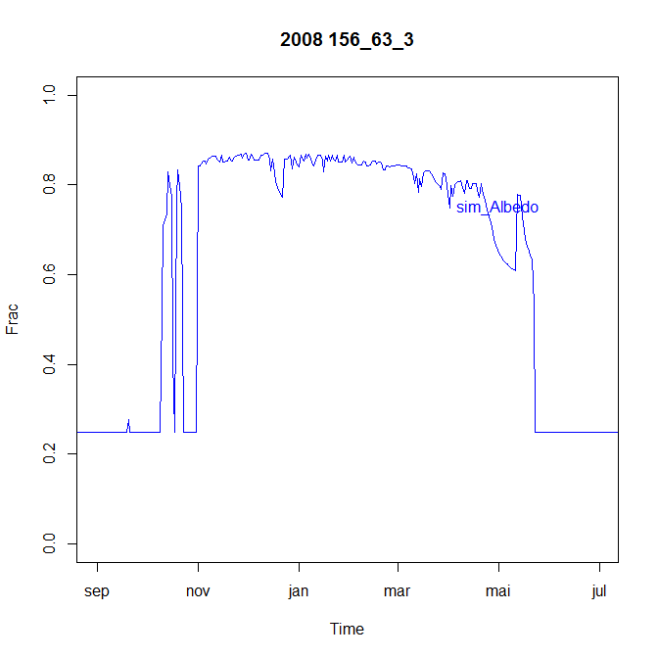

Figure 5. Simulated albedo for the season 2007-8 for the station 156\_63\_3 (UEB approach).

Filefjell val3_3UEBalbedo_iterTemp.tiff

Figure 6. Simulated and observed short- and longwave radiation and albeo at Filefjell at temporal resolution of 3 hours. Input data (precipitation and temperature) are from the disaggregated gridded 3 hourly datatset compiled by Vormoor and Skaugen (2013) for the Filefjell site.

## Discussion

From Table 1, it is clear that the EB approach is superior to the degree day approach. According to the NS criterion 20 out of 31 stations are better modeled with the EB approach. The model applied for 3 hourly input data seem to reproduce the level of radiation fairly well and Figure 7 and 8 shows the potential benefit of using an energy balance approach on a 3 hourly time step. In Figure 7 we find a comparison between the degree- day and EB approach for the Filefjell site. The timing of the EB approach is in Figure 7 is further enhanced using a 3-hourly time step as can be seen in Figure 8.

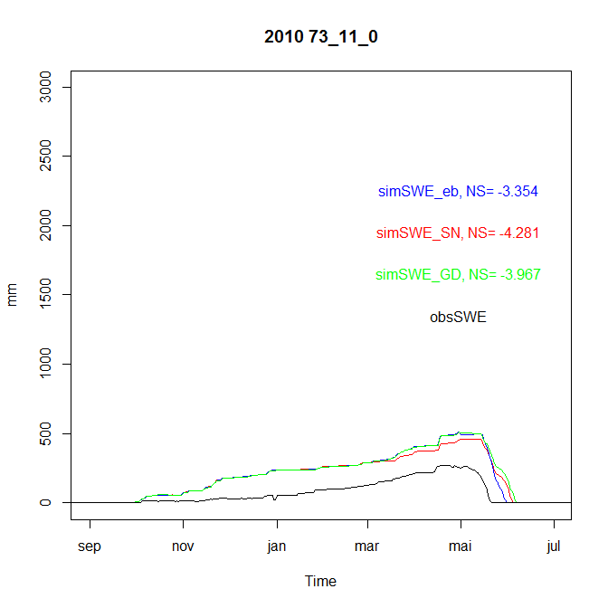

Figure 7. Simulated and observed simulation of SWE. The Figure shows the difference in simulating SWE on a 24 hourly resolution using the degree-day model and the EB approach.

Comp_filefjell24h_sN_3h_Filefjell.tiff

Figure 8. Simulated and observed simulation of SWE. The top panel shows the differences in simulating SWE with the EB approach using 24 hourly and 3 hourly temporal resolution and the lower panels compare the input data for different temporal resolutions.

## Conclusions

The exercise of testing an EB approach, only using precipitation- and temperature data as input, gave satisfactory results when we compared the simulated variables (SWE (24h), radiation and albedo (3h)) to observed, both at 24- and 3 hourly time steps. The obvious benefits are that we avoid the use of calibrated parameters (the degree-day parameter) and the model is easily applied to anywhere due to the dependence of radiation of location.

**References**

Bacellar,S., Oliveira, A.P., Soares,J and Servain,J., 2008.Asessing the diurnal evolution of surface radiation balance over the western region of Tropical Atlantic Ocean using in situ measurements carried out during the FluTuA Project. *Meteorol. Appl*. (doi: 101002/met)

Campbell, G.S. and Norman, J.M., 1998. *An introduction to Environmental Biophysics.* Second ed., Springer New York. p.286.

Dickinson, R. E., A Henderson\_Sellers and P. J. Kennedy, 1993. Bisosphere-Atmosphere Transfer Scheme (BATS) verion 1e as Coupled to NCAR Community Climate Model, NCAR/TN-387+STR, National Center for Atmospheric Research.

Dingman, S. L., 2002. *Physical hydrology.* Second Ed. Prentice Hall, New Jersey. U.S.

Pielke Sr., R.A., G.E. Liston, W.L. Chapman and D.A. Robinson, 2004. Actual and insolation-weighted Northern hemisphere snow cover and sea-ice between 1973-2002. Climate Dynamics, 22,591-595 (doi:10.1007/s00382-004-0401-5).

Goodison, B.E., Ferguson, H.L., McKay, G.A., 1981. Measurement and data analysis. In Gray, D.M., Male, D.H. (Eds.), *Handbook of Snow*, Pergamont Press, Toronto, ON, pp 191-274.

Liston, G.E. 1995. Local advection of momentum, heat and moisture during melt of patchy snow covers. . *J. Appl. Meteorolgy*, **34** 1705-1715.

Liston, G.E and K. Elder. 2006. A meteorological distribution system for high- resolution terrestrial modeling (MicroMet). *J. Hydrometeorology*, **7**(2), 217–234.

Tarboton, D.G and C.H. Luce 1996. Utah energy Balance Snow Accumulation and Melt Model (UEB). Computermodel and technical description and user guide.

Vormoor K. and T. Skaugen, 2013. Temporal disaggregation of daily temperature and precipitation grid data for Norway. *Journal of Hydrometeorology* (in press).

Walter, M.T., Brooks, E. S. McCool, D.K, King, L.G., Molnau, M. and Boll, J., 2005. Process-based snowmelt modeling: does it require more input data than temperature index modeling? *J. Hydrol*. **300**, 65-75.

Web page for calculating sun hours (<http://quantitative-ecology.blogspot.no/2007_10_01_archive.html>)